An Internship Report
Of
PROGRAMMING IN PYTHON WITH AI

Submitted
To
School of Computer Science and Engineering
IILM University, Greater Noida, U.P.
In partial fulfilment of the requirement of degree of
B-Tech (CSE)
By
Roll Number of Student: 2410030544
Name of Student: CHARU ARORA
Batch: 2026–27
Training Duration: 6-week online training
Date of Certification: 14 March 2026

CANDIDATE'S DECLARATION
I, CHARU ARORA, hereby declare that this report titled “Programming in Python with AI” has been prepared to document the six-week online training reflected in my Certificate of Completion. The report is based on the learning modules and information stated on the certificate. Where the certificate does not specify detailed project information, weekly dates, or a particular implementation, this report does not claim those details as verified facts.
I further declare that this report has been prepared for academic submission to the School of Computer Science and Engineering, IILM University, Greater Noida. External learning resources referred to are listed in the references.
Signature: ______________________________
Student Name: CHARU ARORA
Roll No.: 2410030544

ACKNOWLEDGEMENT
I would like to express my sincere gratitude to the training platform and instructors for providing me with the opportunity to complete the six-week online training in Programming in Python with AI. The structured modules introduced me to Python programming fundamentals and related areas of application development.
I am thankful for the learning exposure to variables, basic programming, object-oriented programming, SQLite database connectivity, GUI development using PyQt, applications of Python in different disciplines, the final project, and AI in programming with Python.
I would also like to thank the School of Computer Science and Engineering, IILM University, Greater Noida, for its academic support and encouragement. I am grateful to my family for their continued support throughout my learning.
Student Name: CHARU ARORA
Roll No.: 2410030544

TABLE OF CONTENTS
1. Candidate's Declaration i
2. Acknowledgement ii
3. Training Completion Certificate —
4. Project Description 1
4.1 Introduction 1
4.2 Organization / Training Platform Profile 2
4.3 Problem Statement 3
4.4 Project Objectives 3
4.5 Scope of the Project 4
4.6 Technologies and Tools Used 4
4.7 System Architecture / Application Workflow 5
4.8 Methodology 6
4.9 Expected Outcomes 7
4.10 Certificate and Verification 8
5. Bibliography / References 9

3. TRAINING COMPLETION CERTIFICATE
The following certificate was issued to Charu Arora for successful completion of the six-week online training in Programming in Python with AI. It records 14 March 2026 as the certification date and certificate number gvvq467shwc.
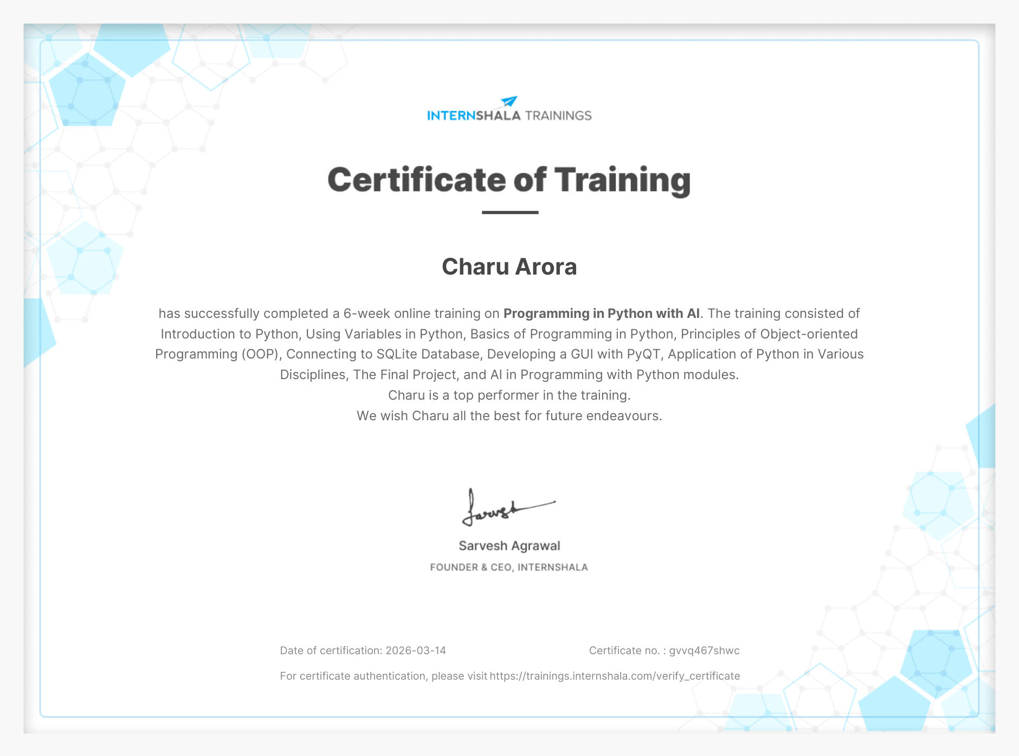

4. PROJECT DESCRIPTION

4.1 Introduction
This report documents the six-week online training titled “Programming in Python with AI” completed by Charu Arora. The certificate lists modules covering Introduction to Python, Using Variables in Python, Basics of Programming in Python, Principles of Object-oriented Programming (OOP), Connecting to SQLite Database, Developing a GUI with PyQt, Application of Python in Various Disciplines, The Final Project, and AI in Programming with Python.
The training progresses from core programming concepts to selected application-development topics. Python's readable syntax and broad ecosystem make it useful for general-purpose programming, database-connected applications, graphical interfaces, and AI-related work.
The certificate records the training as online and six weeks in duration. It also identifies the learner as a top performer. The certificate does not specify exact start and end dates, so this report uses the verified certification date rather than assigning unverified dates to the training period.

4.2 Organization / Training Platform Profile
The uploaded Certificate of Completion confirms the training title, duration, mode, module list, trainee name, certification date, and certificate number. It provides an authentication page: https://trainings.internshala.com/verify_certificate.
The certificate does not include a detailed organization profile, instructor names, or a description of the training provider's operations. Accordingly, this section is limited to the information available from the certificate and does not add unsupported organizational claims.

4.3 Problem Statement
Students beginning software development need to move from theoretical understanding of programming concepts to applying them in practical contexts. Knowing syntax alone is not sufficient to understand how a program can organize data, interact with a database, present a user interface, or connect with emerging areas such as Artificial Intelligence.
The learning problem addressed by this training was to build a foundation in Python and become familiar with related concepts including object-oriented programming, SQLite connectivity, GUI development using PyQt, and AI-oriented programming. The certificate confirms these topics formed part of the training, but it does not provide a separate formal problem statement for the final project.

4.4 Project Objectives
The objectives below are derived from the modules explicitly listed on the completion certificate:
- Understand Python as a programming language and become familiar with its basic syntax.
- Learn how variables are used to store and work with values in a program.
- Build a foundation in basic programming concepts and logical problem solving.
- Understand the principles of object-oriented programming (OOP).
- Learn the role of SQLite and the concept of connecting a Python program to a database.
- Explore graphical user interface development using PyQt.
- Recognize applications of Python in different disciplines.
- Gain introductory exposure to AI in programming with Python.
- Complete the final project component included in the training curriculum.

4.5 Scope of the Project
The scope of the training covers Python fundamentals and selected areas of application development. It includes variables, basic programming, OOP concepts, SQLite database connectivity, PyQt-based GUI development, applications of Python across disciplines, a final project, and AI in programming with Python.
The certificate does not identify the final project's title, detailed requirements, source code, dataset, implementation steps, or evaluation results. Therefore, the report records the final project as a component of the training without inventing a project name or claiming specific functionality. If a separate project submission exists, its verified details can be added as an appendix.

4.6 Technologies and Tools Used
Area | Technology / Topic
Programming language | Python
Programming fundamentals | Variables and basic programming concepts
Programming paradigm | Object-Oriented Programming (OOP)
Database | SQLite
GUI development | PyQt
Application areas | Applications of Python in various disciplines
AI-related learning | AI in Programming with Python
Training activity | Final Project; specific title/details are not stated on the certificate

4.7 System Architecture
The certificate confirms training in several components that can be used together in a Python application. Since it does not provide a system architecture for the final project, the following is a conceptual learning workflow showing relationships between certified topics, not a claim about the architecture of a specific completed project.
Programming foundation: Python syntax, variables, and basic programming logic.
Application structure: OOP concepts for organizing code into reusable components.
Data storage: SQLite connectivity for applications that need to store or retrieve data.
User interaction: PyQt GUI concepts for presenting an interactive desktop interface.
AI awareness: AI in Python as an additional application area explored in the training.
Final project: Application of relevant training concepts in the final project; exact implementation is not stated on the certificate.
Python Basics → Program Logic / OOP → SQLite (where required) → PyQt Interface (where required) → AI Concepts (where applicable) → Final Project

4.8 Methodology
The certificate lists the modules but does not provide a week-by-week schedule. For that reason, the methodology is presented module-wise rather than assigning modules to particular weeks.
No. | Module | Description
1 | Introduction to Python | Introduction to Python as a programming language and preparation for further programming topics.
2 | Using Variables in Python | Learning the role of variables in representing and manipulating values.
3 | Basics of Programming in Python | Building familiarity with core programming concepts and program logic.
4 | Principles of Object-oriented Programming (OOP) | Exploring object-oriented concepts and how they support structured code.
5 | Connecting to SQLite Database | Introduction to database connectivity and persistent data storage in Python applications.
6 | Developing a GUI with PyQt | Exposure to graphical user interfaces and desktop application interaction.
7 | Application of Python in Various Disciplines | Survey of Python's versatility across different application areas.
8 | AI in Programming with Python | Introduction to AI-related programming concepts using Python.
9 | The Final Project | A final project component is included; its specific topic and results are not listed on the certificate.
This module-wise summary follows the wording of the certificate. It does not assert the order of delivery, assessment scores, number of assignments, or project outcomes because those details are not specified in the provided certificate.

4.9 Expected Outcomes
Based on the listed curriculum, the expected learning outcomes include:
- A foundation in Python programming and the use of variables.
- Familiarity with basic programming logic and structured problem solving.
- Introductory understanding of object-oriented programming principles.
- Awareness of how Python can connect to an SQLite database.
- Familiarity with GUI development concepts using PyQt.
- Awareness of Python's applications in different disciplines.
- Introductory exposure to AI-related programming with Python.
- Completion of the final project component included in the training curriculum.
These outcomes describe the learning areas represented by the certificate. Specific proficiency levels or measurable project results are not stated on the certificate.

4.10 Certificate of Completion and Verification
The Certificate of Completion states that Charu Arora successfully completed a six-week online training in Programming in Python with AI. It lists the modules covered, identifies Charu as a top performer, and records the following details:
- Date of certification: 14 March 2026
- Certificate number: gvvq467shwc
- Verification page: https://trainings.internshala.com/verify_certificate
A copy of the certificate is included in Chapter 3 of this report. The certificate confirms completion of training; it does not itself state that the training took place specifically during the summer months. The college's requirements should determine whether this March-certified training qualifies for the summer internship submission.

5. BIBLIOGRAPHY / REFERENCES
- Programming in Python with AI – Certificate of Completion issued to Charu Arora, dated 14 March 2026, Certificate No. gvvq467shwc.
- Certificate verification page printed on the certificate: https://trainings.internshala.com/verify_certificate
- Python documentation: https://docs.python.org/3/
- SQLite documentation: https://www.sqlite.org/docs.html
- Qt for Python documentation: https://doc.qt.io/
Note: References 3–5 are general official documentation resources for topics named in the certificate. Their inclusion does not imply that every resource was used directly during the training.

